**Data Analytics**

**RoadMap:**

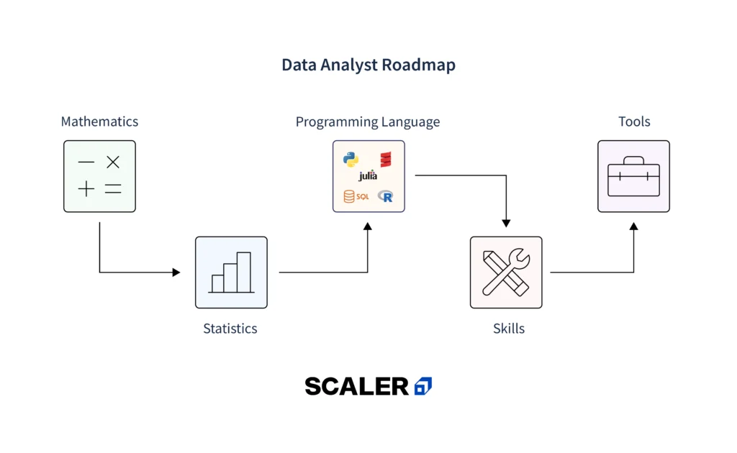

**What is Data Analysis?**

Data analysis is the process of reviewing, cleansing, and organizing data to find patterns and trends. Better decisions can be made with this knowledge in a variety of industries, including marketing, technology, healthcare, and finance.

**Here’s how it works:**

Cleaning Up the Data: Analysts begin by correcting any mistakes or discrepancies in the data. This guarantees the accuracy of the outcomes.

Shaping the Data: Next, they convert the unprocessed data into more easily analysed format, such as tables or charts.

Modelling the Data: Lastly, they generate predictions and find patterns in the data by using models and formulas.

**Who is a Data Analyst?**

A data analyst is a professional skilled in processing and performing statistical analyses on data. They extract meaningful insights from data sets, translate numbers and data into plain English, and help organizations make informed decisions based on data.

Some of the key responsibilities of a data analyst:

Collecting and organizing data from various sources.

Conducting thorough data analysis to identify trends, patterns, and outliers.

Developing and implementing data models and statistical algorithms.

Creating visualizations and reports to present findings.

Collaborating with stakeholders to understand their data needs.

**How Does This Data Analyst Roadmap Help You?**

This Data Analyst Roadmap, curated by industry experts, offers a structured approach to learning, guiding you through essential skills and concepts in a logical progression. It helps you build a strong foundation, advance through key topics, and tackle complex challenges with confidence. By following this roadmap, you’ll gain a comprehensive understanding of data analysis, equipping you with the knowledge and skills to excel in the field and adapt to its evolving demands.

**Step-By-Step Data Analyst Roadmap**

The Step-By-Step Data Analyst Roadmap provides a structured learning path, guiding you from foundational concepts to advanced analytics techniques. Typically, completing this roadmap can take anywhere from a few months to over a year, depending on your starting skill level, learning pace, and the depth of knowledge you aim to achieve. This roadmap ensures you gain a comprehensive and practical understanding of data analysis, preparing you for a successful career in the field.

**Step 1. Mathematics and Statistics**

For data analysis, a strong foundation in mathematics and statistics is required. Data analysis is based on concepts like probability, descriptive statistics, regression analysis, and hypothesis testing. Become familiar with these concepts and how they are used. Online courses, textbooks, and educational resources can provide comprehensive coverage of these topics.

**1.1 Algebra**

Refresh your memory on the basic algebraic operations like multiplication, division, addition, and subtraction. You’ll also encounter concepts like equations, inequalities, and functions.

**1.2 Calculus**

While not always necessary, knowing integrals and derivatives can be useful for advanced data analysis techniques.

**1.3 Linear Algebra**

Learn about linear transformations, matrices, and vectors in linear algebra. These concepts are essential for tasks like dimensional reduction and data manipulation.

**1.4 Probability**

Grasp the concepts of probability distributions, random variables, and how to calculate the likelihood of events.

**1.5 Discrete Mathematics**

Learn about the topics that are helpful for analysing relationships within data, such as set theory, logic, and graph theory.

**1.6 Descriptive Statistics**

Learn how to use statistics such as mean, median, mode, and standard deviation to summarize and describe data sets.

**1.7 Inferential Statistics**

Move beyond describing data to drawing conclusions about populations based on samples. Confidence intervals and hypothesis testing are involved in this.

**1.8 Probability Distributions**

Understand various types of probability distributions (e.g., normal, binomial) and how they model real-world data.

**1.9 Regression Analysis**

Discover how to use methods such as linear regression to model relationships between variables.

**Step 2. Data Exploration using Excel**

Guess what? You already have powerful tools for data exploration: Microsoft Excel! Excel is a widely used spreadsheet tool that offers various functions and features for data exploration and analysis. It lets you clean, organize, and understand data before diving deeper. Here are some important Excel skills to master for data exploration-

Making and managing worksheets

Master important formulas such as Count, Min/Max, and Average.

Use advanced functions such as Concatenate, SumIf, CountIf, SumProduct, and Vlookup, etc.

Pivot tables / Conditional formatting to summarize and analyse data

Different kinds of Charts to show off your findings

Use sensitivity Analysis to understand how changes in variables affect your data.

Building Gantt Chart / Financial Statement

Later, as you explore larger datasets, you’ll encounter SQL, a powerful tool for interacting with and manipulating data stored in databases.

**Step 3. Mastering Other Data Analysis Tools**

Excel is just one of the tools used in data analysis. Explore other tools such as Tableau, Power BI, and Google Data Studio. These tools offer advanced visualization capabilities and interactive dashboards for data exploration. Learn how to connect to different data sources, create meaningful visualizations, and share insights with stakeholders.

**Power BI**

Power BI is a Microsoft tool that specializes in business analytics, allowing users to create reports and dashboards with interactive visualizations. It connects to various data sources and offers real-time insights.

**Tableau**

Tableau is renowned for its powerful data visualization capabilities, enabling users to create interactive and shareable dashboards. It’s user-friendly and supports various data sources.

### Google Data Studio

Google Data Studio offers free tools to convert your data into customizable informative reports and dashboards. It integrates with other Google services, providing a seamless experience.

While these tools are essential for data analysis, gaining expertise in them can be challenging without proper guidance. [Scaler’s Data Science Course provides comprehensive training](https://www.scaler.com/data-science-course/?utm_source=organic_blog&utm_medium=in_content_middle&utm_content=data-analyst-roadmap) on Tableau, Power BI, Google Data Studio, and other industry-standard tools, ensuring you develop the skills needed to effectively analyze and visualize data.

## Step 4. Learn SQL

Structured Query Language (SQL) is a programming language used for managing and manipulating relational databases. It is a crucial skill for data analysts, as it allows you to extract, filter, and aggregate data efficiently. Learn SQL syntax, database design principles, and how to write complex queries. Practice working with real-world datasets to enhance your SQL skills. Here are some essential topics to consider-

* Essential Queries (SELECT, WHERE, ORDER BY)
* Data Manipulation (UPDATE, DELETE, GROUP BY)
* Advanced Queries (Filtering with AND/OR, Aggregation Functions)
* Joins (INNER, LEFT, RIGHT, Self Joins)
* Subqueries (Unlocking Complex Data Relationships)
* Database Management (Creating & Modifying Tables)
* Introduction to SQL Functions (Window Functions, String Manipulation)
* Stored Procedures (Optional: Automate Complex Tasks)

## Step 5. Learn Any Programming Language

While Excel and SQL are powerful tools, learning a programming language expands your capabilities as a data analyst. Choose a language such as Python, R, or Julia, and learn its syntax, data structures, and libraries for data analysis. Here are some popular options to consider:

### 5.1 Python

Python is highly recommended due to its simplicity, versatility, and extensive libraries specifically designed for data analysis. It’s a popular language in data science that is versatile and easy for beginners to learn. It provides robust libraries like NumPy for numerical computation and Pandas for data manipulation.

### 5.2 R Language

R language is specifically designed for statistical computing and data visualization. has an extensive ecosystem of packages for doing statistical analysis and creating eye-catching visuals.

### 5.3 MATLAB

Matlab is a powerful tool for numerical computations that is widely utilized in the engineering and scientific fields. It provides advanced mathematical functions and graphical capabilities.

### 5.4 Python Vs. R, Which one to choose?

Choosing between Python and R depends on your specific data analysis needs. Python is versatile, with extensive libraries for data analysis and machine learning, making it suitable for a broad range of applications. R is renowned for statistical analysis and data visualization, often preferred in academia and research. Consider your project requirements, the community and support available, and your personal or team’s familiarity with the language when making your choice. Better to learn both languages if you are getting started.

## Step 6. Learn Python Libraries for Data Analysis

Now that you’ve understood the Python basics, it’s time to explore powerful Python libraries for data analysis. Python offers several libraries that enhance data analysis capabilities. Here are some essential Python libraries for data analysis-

### 6.1 Pandas

Pandas is a library providing high-level data structures and tools for effective data manipulation and analysis. It’s essential for handling structured data.

### 6.2 Numpy and Scipy

Numpy offers comprehensive mathematical functions, array objects, and tools for working with arrays. Scipy builds on Numpy, providing modules for optimization, linear algebra, integration, and more. Start exploring: the Numpy website and Scipy website.

### 6.3  Matplotlib

Matplotlib is a plotting library for creating static, interactive, and animated visualizations in Python.

### 6.4  Scikit Learn

Scikit Learn is used for machine learning, providing simple and efficient tools for data analysis and modeling.

### 6.5 Seaborn

Seaborn is a library for making statistical graphics in Python, built on top of Matplotlib and closely integrated with Pandas data structures.

## Step 7. Other Important Data Analytics Skills To Learn

Beyond core technical skills, data analysts need to master additional competencies to effectively analyze and interpret data, communicate findings, and make informed decisions.

Some other skills to learn are –

### 7.1 Exploratory Data Analysis (EDA)

Exploratory Data Analysis is a critical step in the data analytics process, allowing analysts to understand the data’s distributions, main characteristics, and underlying patterns. It involves using statistical graphics and other data visualization methods to summarize the data’s essence without making assumptions.

### 7.2 Time Series Analysis

Time Series Analysis is essential for analyzing data points indexed in time order. It’s vital for understanding trends, seasonality, and cyclical patterns in data, helping predict future values based on past data, crucial in financial, weather forecasting, and inventory studies.

### 7.3 Big Data Analysis

Big Data Analysis involves extracting valuable information from large, complex data sets. Analysts need to manage, process, and analyze these vast amounts of data efficiently, often requiring knowledge of specific tools and frameworks designed for big data environments.

### 7.4  Advanced Data Visualization

Advanced Data Visualization transcends basic graphs, employing sophisticated techniques to illustrate complex relationships and trends in data. It enhances the interpretability of data, facilitating better decision-making by providing clear, impactful visual narratives.

### 7.5  Project Management Skills

Project management is key for data analysts to effectively plan, execute, and close projects. These skills ensure that data projects meet objectives, are delivered on time, and within budget, requiring adept coordination of resources, data, and stakeholder expectations.

### 7.6  Domain-Specific Knowledge

Domain-specific knowledge allows data analysts to apply their technical skills within a specific context, enhancing the relevance and impact of their analysis. Understanding industry-specific challenges and data nuances enables more accurate, insightful analytics.

### 7.7 Soft Skills Development

Soft skills like communication, teamwork, and critical thinking are indispensable for data analysts. They foster effective collaboration, clear presentation of findings, and the ability to translate complex data insights into actionable business strategies.

If you’re looking to build a strong foundation in all these essential data analysis skills, from technical expertise to soft skills mastery, [Scaler’s Data Science Course offers a comprehensive curriculum](https://www.scaler.com/data-science-course/?utm_source=organic_blog&utm_medium=in_content_middle&utm_content=data-analyst-roadmap) designed to prepare you for a successful career in data.

## Step 8. Continuous Learning and Networking

Data analysis is a constantly evolving field, with new tools, techniques, and technologies emerging regularly.

* Stay updated with the latest trends and advancements by attending webinars, conferences, and workshops.
* Engage with the data analysis community through online forums such as [Cross Validated on Stack Exchange](https://stats.stackexchange.com/), social media groups, and professional networking events or platforms like LinkedIn.
* Collaborate with fellow analysts, share knowledge, and learn from their experiences. Continuous learning and networking will help you stay ahead in this dynamic field.

## Final Step: Case Studies, Project, Portfolio, and ATS Resume

Learning is just the first step. Now it’s time to showcase your data analysis skills! Here’s how:

**Real-world case studies**: Apply your skills to real-world case studies. Case studies let you apply your skills to solve problems faced by businesses. Websites like[Kaggle](https://www.kaggle.com/) offer a plethora of case studies across various industries.

**Projects**: Work on data analysis projects to demonstrate your competence as a data analyst. Explore diverse datasets, solve complex problems, and present your findings effectively. You can work on the following data analysis projects-

* Colour Detection Project
* Exploratory Data Analysis Projects (EDA)
* Fake News Detection
* Sales Forecasting Analysis
* Customer Segmentation Analysis
* Sentiment Analysis
* Chatbots
* Social Media Reputation Monitoring

Use platforms like **GitHub** to host and showcase your project work.

**Strong online presence**: Build an effective portfolio on platforms like LinkedIn showcasing your work, including visualizations, reports, and analysis. Highlight your data analysis projects. [Tableau Public](https://public.tableau.com/app/discover) provides examples and inspiration.

**ATS-Friendly Resume**: Moreover, optimize your resume for Applicant Tracking Systems (ATS) by incorporating relevant keywords, highlighting your skills and accomplishments, and tailoring it to specific job descriptions.

## Data Analyst Career Opportunities With Salary

There is a huge demand for qualified data analysts. In fact, the **Bureau of Labor Statistics projects a 30% job growth for data analysts and statisticians between 2022 and 2032**, which is much faster than the average for all occupations. The growing volume of data produced by companies and organizations of all sizes is the main cause of this quick expansion.

However, data analysts typically earn competitive salaries. **Data analysts may expect to make between $62,000 and $96,000 annually on average in the United States, and between ₹4L and ₹10L annually in India, according to Glassdoor.**  Industry, location, and level of expertise all affect data analyst salaries. Here are some average base salaries for some of the top data analyst job roles according to Glassdoor:

| **Top Job Profiles** | **Salary in India (Per Annum)** | **Salary in US (Per Annum)** |
| --- | --- | --- |
| Entry-level Data Analyst | ₹3L – ₹6L | $55T – $83T |
| Data Analyst | ₹4L – ₹10L | $62T – $96T |
| Senior Data Analyst | ₹7L – ₹17L | $96T – $1L |
| Operations Analysts | ₹4L – ₹6L | $55T – $85T |
| Business Intelligence Analyst | ₹5L – ₹11L | $86T – $124T |
| Healthcare Data Analyst | ₹5L – ₹8L | $62T – $94T |
| Financial Data Analyst | ₹4L – ₹7L | $67T – $95T |
| Statistical Analyst | ₹6L – ₹12L | $74T – $113T |
| Supply Chain Analyst | ₹5L – ₹9L | $54T – $1L |
| Systems Analysts | ₹4L – ₹13L | $90T – $137T |
| Data Quality Assistant | ₹3L – ₹8L | $48T – $74T |

For people who enjoy working with data and solving problems, a career in data analysis is an excellent choice because of its strong job demand and significant income potential.

## What’s Next? How to Start Your Career in Data Analytics?



So, you’re interested in becoming a data analyst? That’s very impressive! There are several options to get you started, which is fantastic news. Here are some routes to consider that are flexible enough to fit your needs-

1. **Formal Education**: Enrolling in a data science boot camp or a degree program in statistics, computer science, or a related field can provide a more structured learning environment.
2. **Self-learning**: This route allows you to learn at your own pace and explore areas that particularly interest you. Here are some resources to get you going:

* Books: There are many great books available on data analysis. A good starting point might be "Data Analytics using Python" or "Numsense! Data Science for the Layman".
* **Online Communities**: Joining online communities like Kaggle and LinkedIn allows you to connect with other aspiring and experienced data analysts. You can participate in discussions, ask questions, and even find datasets to practice your skills on.

1. **Consider Specialized Certifications or Courses**: While not mandatory, pursuing data analysis certifications and courses can validate your skills and enhance your resume. Many free and paid online courses can teach you data analysis skills. [Scaler’s Data Science Course](https://www.scaler.com/data-science-course/?utm_source=organic_blog&utm_medium=in_content_footer&utm_content=data-analyst-roadmap) offers a comprehensive and immersive boot camp experience designed to equip you with the practical skills and industry knowledge needed to launch your data analyst career.

## Conclusion

The journey to becoming a successful data analyst requires dedication, continuous learning, and the right skill set. Following this step-by-step roadmap will provide you with a comprehensive guide to developing the necessary ski